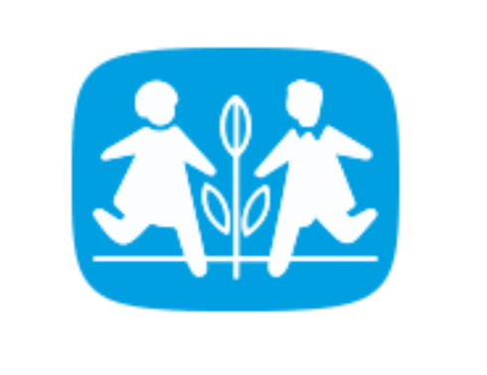 Blood donation Access database project

Group members
1. Niaomi Abel
2. Yenatfant Tilahun

Acknowledgement
We would like to express our deep gratitude to our esteemed group members for their unwavering dedication, exceptional teamwork, and tireless effort in developing the blood donation database project. Each member's unique skills, expertise, and unwavering commitment were instrumental in the successful completion of this project.
From the initial planning stages to the final implementation, every member played a crucial role in contributing their knowledge, creativity, and problem-solving abilities. Their collective efforts and collaborative spirit have not only enriched the project but also fostered a supportive and dynamic working environment.
We are truly appreciative of the countless hours spent brainstorming, researching, designing, and refining the database, as well as the numerous discussions and debates that ultimately led to innovative solutions and a high-quality end product. The diverse perspectives and ideas brought forth by each team member have undoubtedly elevated the project to new heights.
In essence, we extend our heartfelt thanks to our remarkable group members for their outstanding contributions, teamwork, and perseverance. It is through their combined efforts that we have been able to create a meaningful and impactful project that will benefit the community and make a difference in the lives of many.

Table content
1) Background • • • • • 3
2) objective. Of the project • • • • • 4
3) function • • • • • • • • • • • • • • • • 4
Background
Hey there! So, let's talk about this cool project we've been working on – a Blood Donation Database on Access. It's all about helping out our community and making a difference in people's lives by keeping track of blood donors, blood bankers, and blood donations. Sounds pretty important, right?
So, we've got three main tables in our database: the first one is all about the awesome blood donors who are willing to roll up their sleeves and give the gift of life. The second table is for the amazing blood bankers who store and distribute blood to those in need. And the third table is for keeping track of the life-saving blood donations that happen.
We wanted to create this database to make it easier for everyone involved in the blood donation process to stay organized and connected. With everything in one place, it's much simpler to coordinate donations, track inventory, and reach out to donors when needed.
By developing this database, we hope to streamline the blood donation process, ensure a steady supply of blood for those in need, and ultimately save lives. It's pretty awesome to think that something we're working on could have such a big impact on our community.
So, yeah, that's the gist of our Blood Donation Database Project. We're super excited about it and can't wait to see how it helps make a positive difference in the world. Thanks for reading

Objective of the project
The key objective of the Blood Donation Database Project is to develop a centralized database system to streamline the management of blood donors, blood bankers, and blood donations. This project aims to enhance coordination, tracking, and communication among stakeholders involved in the blood donation process, optimizing workflow efficiency and ensuring accurate inventory management. The primary goal is to improve accessibility to critical information for medical professionals and individuals in need of blood transfusions, ultimately contributing to the promotion of public health and saving lives through a responsive blood donation infrastructure.
Functions
1. Donor Registration and Management
2. Donor Eligibility Screening
3. Blood Bank Inventory Management
4. Donor Appointment Scheduling
5. Blood Donation Tracking
6. Communication and Notification
7. Reporting and Analytics
8. Security and Privacy Measures
9. Integration with Healthcare Systems
10. Donor Engagement and Recognition

